
St Hilda’s Priory Chapel
20th September 2026
St Matthew Apostle & Evangelist
Hymn CP 267 Thou whose almighty word
The Collect
O almighty God, whose blessed Son called Matthew the tax-collector
to be an apostle and evangelist: give us grace to forsake the selfish pursuit of gain and the possessive love of riches that we may follow in the way of your Son Jesus Christ, who is alive and reigns with you,
in the unity of the Holy Spirit, one God, now and for ever. Amen.
Reading from the book of Proverbs 3.13-18
Happy are those who find wisdom,
and those who get understanding,
for her income is better than silver,
and her revenue better than gold.
She is more precious than jewels,
and nothing you desire can compare with her.
Long life is in her right hand;
in her left hand are riches and honour.
Her ways are ways of pleasantness,
and all her paths are peace.
She is a tree of life to those who lay hold of her;
those who hold her fast are called happy.
Proverbs 3.13-18

This is the word of the Lord. Thanks be to God.
Psalm 119.65-72
Refrain: Lead me, O Lord, in the path of your commandments
You have dealt graciously with your servant, according to your word, O Lord. O teach me true understanding and knowledge, for I have trusted in your commandments. Before I was afflicted I went astray, ♦
but now I keep your word.
You are gracious and do good; O Lord, teach me your statutes. The proud have smeared me with lies, but I will keep your commandments with my whole heart. Their heart has become gross with fat, but my delight is in your law.
It is good for me that I have been afflicted, that I may learn your statutes. The law of your mouth is dearer to me than a hoard of gold and silver.
Refrain: Lead me, O Lord, in the path of your commandments

Reading from the 2nd letter of Paul Corinthians
Since it is by God’s mercy that we are engaged in this ministry, we do not lose heart. We have renounced the shameful things that one hides; we refuse to practise cunning or to falsify God’s word; but by the open statement of the truth we commend ourselves to the conscience of everyone in the sight of God. And even if our gospel is veiled, it is veiled to those who are perishing. In their case the god of this world has blinded the minds of the unbelievers, to keep them from seeing the light of the gospel of the glory of Christ, who is the image of God. For we do not proclaim ourselves; we proclaim Jesus Christ as Lord and ourselves as your slaves for Jesus’ sake. For it is the God who said, ‘Let light shine out of darkness,’ who has shone in our hearts to give the light of the knowledge of the glory of God in the face of Jesus Christ.
2 Corinthians 4.1-6
This is the word of the Lord. Thanks be to God.
Gradual CP 220 How beauteous are the feet
Gospel Acclamation
Alleluia, alleluia.
I have called you friends, says the Lord,
for all that I have heard from my Father
I have made known to you.
Alleluia.
Hear the Gospel of our Lord Jesus Christ according to Matthew.
Glory to you, O Lord.
As Jesus was walking along, he saw a man called Matthew sitting at the tax booth; and he said to him, ‘Follow me.’ And he got up and followed him.
And as he sat at dinner in the house, many tax-collectors and sinners came and were sitting with him and his disciples. When the Pharisees saw this, they said to his disciples, ‘Why does your teacher eat with tax-collectors and sinners?’ But when he heard this, he said, ‘Those who are well have no need of a physician, but those who are sick. Go and learn what this means, “I desire mercy, not sacrifice.” For I have come to call not the righteous but sinners.’ Matthew 9.9-13
This is the Gospel of the Lord. Praise to you, O Christ
Sermon / Creed / Intercessions
The Peace
May the God of peace sanctify you:
may he so strengthen your hearts in holiness
that you may be blameless before him
at the coming of our Lord Jesus with his saints.
The peace of the Lord be always with you
and also with you.
Let us offer one another a sign of peace.
Offertory CP 469 I heard the voice of Jesus say

Prayer after Communion
Silence is kept.
Almighty God, who on the day of Pentecost sent your Holy Spirit to the apostles with the wind from heaven and in tongues of flame, filling them with joy and boldness to preach the gospel: by the power of the same Spirit strengthen us to witness to your truth and to draw everyone to the fire of your love; through Jesus Christ our Lord. Amen
The Blessing
Final CP 230 Ye watchers and ye holy ones
The Dismissal
Go in peace to love and serve the Lord.
In the name of Christ. Amen.

The Eucharist will be celebrated during the week at the following times:
Sunday | Sept | 20 | 9.30 | Fr Paul | St Matthew Ap Evan.
Monday |  | 21 | - | -
Tuesday |  | 22 | - | - | Feria
Wednesday |  | 23 | 12.30 | Fr Paul | Ember Day
Thursday |  | 24 | 12.30 | Fr Paul | Feria
Friday |  | 25 | 10.30 | Fr Paul | Ember Day
Saturday |  | 26 | 8.00 | Fr Paul | Ember Day
Sunday |  | 27 | 9.30 | Fr Paul | Trinity 17

There will be Coffee after the service today
Please join us for fellowship

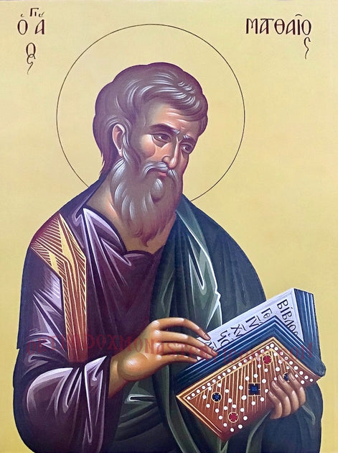
Greek orthodox icon of Saint Matthew the Evangelist

Copyright acknowledgement (where not already indicated above):
Some material included in this service is copyright: © 1989 National Council of the Churches of Christ, USA
Some material included in this service is copyright: © The Archbishops' Council 2000
Some material included in this service is copyright: © The Archbishops' Council
Collect (Matthew) © The Crown/Cambridge University Press: The Book of Common Prayer (1662)

